**Project Report**

**Online Shopping Management System**

**Submitted by**

**Faisal Shahzad**

**MCEIT-11-25**

**2011-2015**

**Supervisor: Mr.Sohaib Hafeez**



**DEPARTMENT OF INFORMATION TECHNOLOGY**

**GOVT.EMERSON COLLEGE,**

**MULTAN PAKISTAN.**



IN THE NAME OF ALLAH THE GREAT BENEFICENT THE MOST MERCIFUL

**FINAL APPROVAL**

This is to certify that we have read this report submitted Faisal Shahzad and it is our judgment that this report is of sufficient standard to warrant its acceptance by Govt.Emerson college, Multan for the degree of BS-IT (Information Technology).

# *Committee:*

**1. External Examiner ______________________**

**2. Supervisor ________________**

Mr. Sohaib Hafeez

Department of Information Technology

G.E. College,Multan

**3. Head of Department ________________**

Prof. Ch.Nawaz

Department of Information Technology

G.E. College,Multan

**DEDICATION**

To My Loving Parents whose care and prayers had been with me all the time during my academic life and without their spiritual presence and guidance it was almost impossible for me to reach this stage of finalizing and passing my masters in computer science,

And to Respected Teachers who had opened a new era to me and showed me a new horizon of success and knowledge and it was their guidance and help that I am able to erect my head as a successful student,

And to my dear friends who had been with me all the days and nights long in the preparations and common studies activities,

And to those dear fellows and my dear ones who kept praying for my success just for nothing but only to see my successful student of my career.

**Acknowledgement**

Great **ALLAH,** the most gracious, merciful and beneficent has given me the strength and make me able to fulfill the requirements of this project successfully in a short period of time within limited resources and knowledge.

I express my gratitude and obligations to **Prof.Ch Nawaz Sb,** Head of Department of Information Technology,G.E. College, Multan, who did his selfless and tireless efforts for providing us all facilities throughout the academic session and their kind and loving attitude always encouraged us to work hard.

I feel great honor to express my sincere and cordial thanks to respected teacher,

**Mr.Sohaib Hafeez** for his guidance, sympathetic attitude, solving related problems that I faced in project completion period. He guided me in critical times and helped me whenever I needed.

I am also grateful to my honorable fellows who helped me a lot, enforcing me to do work with full courage and devotion. They gave me knowledge to solve critical problems.

At the end I feel very respect and happiness towards my family members who gave me resources, lot of encourage and day-by-day prayers with love. Specially my parents prayed for my success and encouraged me to do the given task with full zeal and zest.

***Faisal Shahzad***

**PROJECT BRIEF**

|  |  |
| --- | --- |
| **Project Name:** | Online Shopping Management |
| **Undertaken by:** | Faisal Shahzad |
| **Supervised by:** | Mr. Sohaib Hafeez |
| **Date of starting:** | Dec 28,2015 |
| **Date of Completion:** | April 29, 2016 |
| **Operating System:** | Microsoft Windows 7 Ultimate |
| **System Used:** | Dual core |
| **Web Server:** | xampp Server |
| **Source Language:** | PHP,Java script,HTML,CSS |
| **Back-End Designed in:** | MySQL Server |

**ABSTRACT**

PHP is the best tool for developing web based applications. PHP is an open source language. Although there are number of languages that support database applications but are not as flexible as PHP. It provides the platform independence. It also provides a number of built in controls for database applications.

Since in database applications security is the main and fundamental thing so to provide the secure application MySQL Server is used as backend database. The main reason to use MySQL Server was to make the data secure and also it provides great compatibility with PHP and App Server, and also provides faster data manipulation and insertion as compared to other technologies such as oracle. So combination of above mentioned tools make this project user friendly and according to the needs of the organization.

The objectives of the project are

1. Be aware to students and parents both with future events alerts.
2. Provide course related books through small school library.
3. Provide facility to students to get free online admission in school.
4. Students and parents can concern their problem to principle, staff, and teacher via message.
5. Up to date with Principle and exam controller message
6. Provide facility of latest news
7. Be aware to students and parents with role of every person in our organization.

**Chapter 1**

**INTRODUCTION**

**1.1 Introduction**

Online shopping is the process whereby consumers directly buy goods, services etc. from a seller interactively in real-time without an intermediary service over the internet.

Online shopping is the process of buying goods and services from merchants who sell on the Internet. Since the emergence of the World Wide Web, merchants have sought to sell their products to people who surf the Internet. In fact, people can purchase just about anything from companies that provide their products online. Books, clothing, Computers & its accessories, household appliances, toys, hardware, software, and health insurance are just some of the hundreds of products consumers can buy from an online store. Online shopping transactions occur instantly-saving you time to get your other errands done!

The name of my project is **“**Online Mobile shopping (OMS)**”**. This is a website that will provide a facility of online shopping. In this project there is a beautiful collection of Computers& its accessories of different categories. The users can easily view and select Computers & its accessories of their choice. What's even more useful is the ability to compare items, similar or not, online. You can search through multiple stores at the same time, comparing material quality, sizes and pricing simultaneously. It is a general project & I have selected this project to work out for providing the users better facility of shopping at just one door step. Additionally, unlike a store, online shopping has friendly customer service representatives available 24 hours a day, 7 days a week to assist you with locating, purchasing and shipping your merchandise. All operations are well-organized & offering charming attraction for its customers.

To achieve this end, this website is providing:

* Most modern & creative Mobiles& its accessories
* Best Quality.
* Infrastructure

.

* 1. **Main Theme**

The main theme of this project is to provide the users an ease of access to the variety of qualityof Mobiles& its accessories with so many facilities to accomplish their demands. Now it’s all about just a single click. Here you can take a look of all the items any time in detail with its description available. You don’t have to bind yourself consistently for a long time like in markets instead you are free to visit and order any product any time in a relax environment having your eatables with you at home.

**1.3** **Scope of the Project**

Following are the foremost features of the site:

* Secure payment processes.
* User’s profile system.
* Quality products.
* Finding current rates online.
* Give order online.

**1.4Objectives of the Project**

Following are the few objectives:

* The system will provide a user-friendly environment so that any person having the basic knowledge of Internet may efficiently order the product.
* Payment will be done according to the terms and conditions.
* It will help in the fast retrieval of data.
* Assures the security and safety of data.
* It will provide reliable and flexible system.
* Provide home delivery and through ATM.
* Sell at lower rate due to less over head.
* System will focus on speed & accuracy provided during the data processing.

**1.5 Introduction to Organization**

The online Mobile Store& its accessoriesneed to maintain a collection of Mobiles& its accessories with a large number of different categories. Mobiles& its accessories are meant to provide different Mobiles& its accessories with different categories. The purpose of our website is the same as to provide people an open platform. If the user has an internet access then user has to only login into our website and can access the products with details attached and buy what they want any time. The products are displayed in a quality images format. There is an admin that provides all these services to users. Our website is designed to benefit the users. With recent improvements in internet and mobile phone technology, users can now access their favorite websites. You don’t even need PC or laptop; your mobile phones will do just fine!

**1.5.1Organizational Setup and Structure**

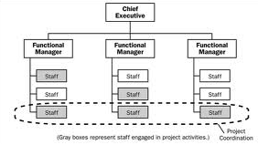

**1.5.2 Main Aim and Work Environment**

### Sell Configured to Ordered Products.

### The system shall display all the products that can be configured.

### The system shall allow user to select the product to configure.

### The system shall display all the available components of the product to configure

### The system shall enable user to add one or more component to the configuration.

#### The system shall notify the user about any conflict in the current configuration.

#### The system shall allow user to update the configuration to resolve conflict in the current configuration.

* The system shall allow user to confirm the completion of current configuration.

### Provide comprehensive product details.

#### The system shall display detailed information of the selected products.

#### The system shall provide browsing options to see product details.

### Maintain customer profile

* The system shall allow user to create profile and set his credential.
* The system shall authenticate user credentials to view the profile.
* The system shall allow user to update the profile information.

### 

### Provide personalized profile

The system shall display both the active and completed order history in the customer profile..

* The system shall allow user to select the order from the order history.
* The system shall display the detailed information about the selected order.
* Provide Shopping cart facility
* The system shall provide shopping cart during online purchase.
* The system shall allow user to add/remove products in the shopping cart.

### Allow online change or cancellation of order.

* The system shall display the orders that are eligible to change.
* The system shall allow user to select the order to be changed.
* The system shall allow user to cancel the order
* The system shall allow user to change shipping, payment method.
* The system shall notify the user about any changes made to the order.

### Web Based Product

* There are no memory requirements
* The computers must be equipped with web browsers such as Internet explorer.
* The product must be stored in such a way that allows the client easy access to it.
* Response time for loading the product should take no longer than five minutes.
* A general knowledge of basic computer skills is required to use the product .

**1.5.1 OSC Problem Statements**

* OSC Problem Statement Customer can browser through the product catalog and add the items to shopping cart. He can proceed to checkout as long as his shopping cart is not empty. Customer will require to login to the system when he proceed to checkout, The order will charge to the credit card registered in customer's account also Through Home Delivery.Upon order received, the sales staff will process the order by charge to customer's credit card. Once the order has been charged, he will then mark the order as paid and pass to courier company and deliver them to customer. If the items customer ordered is out of stock, then the order will mark as on hold. Once the item(s) arrived, the order will pass to courier company for delivery. Courier company will pack the item with standard packaging, but if the order is marked as gift, then the the items will pack as gift. If the items arrived with damage, customer can return it by register in the online shop. Courier company will collect the item from customer and sales staff will refund the money for that item. Marketing staff responsible to maintain the product catalog.

**Chapter 2**

**System Analysis**

**2.1 Feasibility Study**

A feasibility study is a preliminary study undertaken before the real work of a project starts to ascertain the likelihood of the project's success. It is an [analysis](http://www.businessdictionary.com/definition/analysis.html) and [evaluation](http://www.businessdictionary.com/definition/evaluation.html) of a proposed [project](http://www.businessdictionary.com/definition/project.html) to determine if it (1) is technically feasible, (2) is feasible within the [estimated cost](http://www.businessdictionary.com/definition/estimated-cost.html), and (3) will be [profitable](http://www.businessdictionary.com/definition/profitability.html). Feasibility studies are almost always conducted where large [sums](http://www.businessdictionary.com/definition/sum.html) are at stake. It is also [called](http://www.businessdictionary.com/definition/call.html) feasibility analysis. In this phase, the Technical, Operational and Economical feasibility conditions for the system are needed to be satisfied.

* **Technical Feasibility**

If the organization can obtain the equipment and personnel to develop (or purchase) and operate the system then the system request for the technical feasibility satisfaction is fulfilled. It is frequently the most difficult area because objectives functions and performance are somewhat hazy.

* **Operational Feasibility**

The proposed system will be user friendly and menu driven and employee or end user will operate the system efficiently after some training. The proposed system will be required to fulfill all operational requirements of the user.

* In the new system the customer can purchase the products online.
* The customer is free to view all the products every time he wants.
* **Economical Feasibility**

A system request is assured to be economically feasible if the project benefits of the proposed system outweigh the estimate costs involved in developing (or purchasing), installing and operating it. Costs can be one-time or continuing and can be incurred at various times during project development and use. To determine the economic feasibility of the project, we need to estimate the costs in each of following areas:

* People.
* Hardware.
* Software development.
* Training.
* Other required cots.

**2.2 Existing System: Data Gathering**

“Data gathering is an art and a science”

The approach and manner in which information is gathered require persons with sensitivity, common-sense, and knowledge of what and when to gather and what channel to use in securing the information. Before one determines where to go for information or what tools to use, the first requirement is to check out what information to gather.

* **Information about the firm**

Information about the organization’s policy, goal, objective, and structure explain the kind of environment. Company policies are guideline that determines the conduct of business. Information from employee manuals, orientation pamphlets, annual company reports, and the likes helps an analyst from opinions about the goals of the organization.

* **Origin of Information**

Information is gathered from two principle sources: Personnel or Written documents from within the organization and from the organization’s environment. The primary internal sources are:

* Financial reports
* Personal staff
* Professional staff
* System documents or manual

The primary external source may include the vendors.

* **Information Gathering Tools**

The analyst must decide on the information gathering tool and how it must be used. Although there is no standard rule specified for the use of the tools, but the only important rule is that information must be acquired accurately. Following are some tools mentioned below:

* On-site Observation.
* Interviews and Questionnaires.

|  |  |  |
| --- | --- | --- |
| 1. **Questionnaires**   A form containing a set of questions, especially one addressed to a statistically significant number of subjects as a way of gathering information for a survey.In contrast to the interviews is the questionnaire. By its nature it has following advantages:   * It is economical and requires less skill to administrator than the interview. * Unlike the interview, which generally questions one when subject at time, a questionnaire can be administered to large number individuals simultaneously. * The standardized wording and order of the questions and the standardized instructions for reporting responses ensure uniformly. * In contrast to the interview situation is rarely uniform from one interview to the next.   Some questions that were asked are following:  Q1: Is Online Shopping better than Traditional Shopping?   1. Yes 2. No   Q2: Do you prefer online shopping?   1. Yes 2. No 3. Depends on mood | | |
| 1. **Sampling & Observations**   Another information gathering tool used in system studies is Observation. It is the process of recognizing and noticing people, objects and occurrences obtaining information. The major objectives of observation is to get as close as possible to the real system being studied. For this reason it is important that the system analyst is knowledgeable about the general makeup and activities of the system.   * **Natural or Contrived**   A natural observation occurs in a setting such as the employee’s place of work; a contrived observation is by the observer in a place like a laboratory.  Obtrusive or Unobtrusive  An obtrusive observation takes place when the respondent knows he/she is being observed; an unobtrusive observation takes place in a contrived way such as behind a one way mirror.   * **Direct or Indirect**   A direct observation takes place when the analyst actually observes the subject or the system at work. In an indirect observation, the analyst uses the mechanical devices such as cameras and videotapes to capture the information   * **Structured or Unstructured**   In the structured observation, the observer look for the record of specific actions performed such as number of soups can a shopper picks up before choosing one; Unstructured methods place the observer in a situation whatever might be patient at the time.   * 1. **Existing System: Data Analysis**   Data Analysis (DA) is a practice of science for examining the raw data to get organized so that useful information can be extracted from it. The process of organizing and thinking about data is a key to understanding what the data does and does not contain. In its raw form, this information can be incredibly useful, but also overwhelming. Over the course of the data analysis process, the raw data is needed to be ordered in such a way which will be useful. Data analysis is used to determine whether the systems in place effectively protect data, operate efficiently and succeed in accomplishing an organization's overall goals by bringing out modifications in the existing system.Several steps are involved at analysis stage while designing a database. Some of these step are below:   1. Feasibility Study 2. Requirement Analysis 3. Project Planning 4. Data Analysis | | |
| **2.4 Requirements Engineering**  This project of OSC used a Agile model as the basic need and requirement of the engineering. The Agile model is a popular version of the systems development life cycle model for software engineering. Often considered the classic approach to the systems development life cycle, the Agile came about as a “solution”to the disadvantages of waterfall methodology instead of sequance of diagram process,agile follows incremental approch. Developer start off with a simplistic project design.and work on small modules the work on these modules is don in weekly or monthly sprints,at the end of each sprint, project properties are evaluated and test and run. Each release is throughly tested to ensure software quality is maintained.  C:\Users\RAMZAN JALLVI\Desktop\Agile-model.jpg  **When to use the waterfall model:**   * Requirements are very well known, clear and fixed * When new changes are needed to implementedchanges can be implemented on little cost. * when rapid production is more important than the quality of products. * Whenclients will be able to chance the scope of project. * It is used for time critical application. * Product definition is stable. * Technology is understood. * There are no ambiguous requirements. * Ample resources with required expertise are available freely. * The project is short. | |
| **2.5Deliverables**  A project management term for the quantifiable goods or services that will be provided upon the completion of a project. Deliverables can be tangible or intangible parts of the development process, and are often specified functions or characteristics of the project.  Project deliverables are the outputs got from a project that normally give a beneficial change. They are provided to the project sponsors at the end of every project. They can be for both internal users and the external customers.  The project brief will identify the goals of the project and may express some of these as key objectives. At an early stage of planning you will need to identify all of the project objectives and the deliverables that are implied or required from each objective.  Each objective will identify a clear outcome. The outcome is the deliverable. In some cases, the outcome will be some sort of change achieved and in other cases it will be the production of something new. In either case, the project deliverables should be identified so that it will be easy to demonstrate that they have been achieved.  Need to be handed over to someone authorized to receive them; At the handover, there should be a formal acknowledgement that the specification has been fully met and each item has been ‘signed off’ as fully acceptable; The deliverable will be something for which users will need some training to use or something that needs to be implemented in some way. In these cases, once the deliverable has been identified, it is important to agree who will be responsible for the ongoing training or implementation, so that there are no misunderstandings about the boundary of the project. | |
|  |

**Chapter 3**

**System Design**

**3.1 Introduction to System Design**

System design is a solution, “how to” approach to the creation of a new system. This important phase is composed of several steps. It provides the understanding and procedural details necessary for implementing the system. Emphasis is on translating the performance requirements into design specifications. Design goes through logical and physical stages of development. Logical design reviews the present physical system and prepares the input and output specification. The physical design maps out the details of the physical system, plans the system implementation, devices a test and implementation plans, and specify any new hardware and software.

**3.2 System Design using UML**

UML is an object -oriented modelinglanguage standardized by the Object Management Group(OMG) mainly for software systems development. UML is used to specify, visualize, modify, construct and document the artifacts of an object-oriented software-intensive system under development.

**3.2.1 Use Case Diagrams**

Use case diagrams show the interaction between use cases, which represent the system functionality, and actors, which represents the people, or systems that provide or receive information from the system.

* Use Case Diagrams represent structural information of the system.
* UML also represents general types of behavior and different aspects of interactions.

Use Case is the way of interaction of actors with the system. In simple words, use case diagram shows that how the system to be used by customers and clients of the system.

There are two actors that performing their specific role in the accomplishment of this system. These actors perform actions on the input and generate the output for the next phase. My project includes twotypes of actors.

1. Customer
2. Admin

The Use Case diagrams of this project are given.

**3.2.1.1 Use Case Diagram (Administrator)**

The given use case diagram dictates the actions performed by the admin.

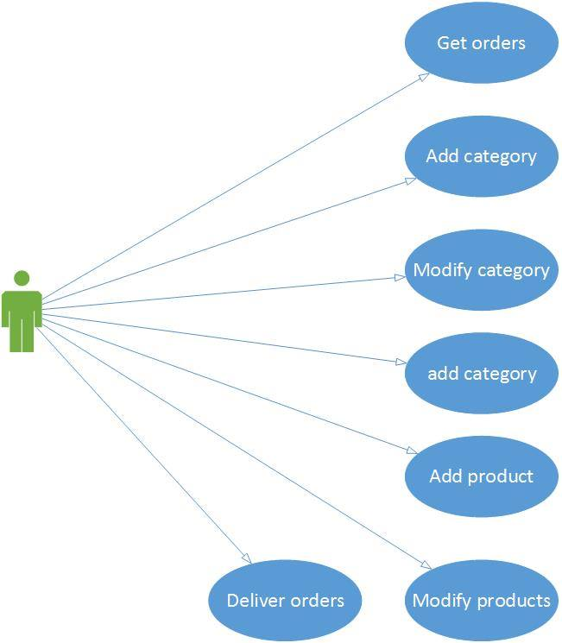

**Use Case Diagram for Administrator**

**3.2.1.2 Use Case Diagram (Customer)**

The given use case diagram dictates the actions and operations performed by the customer and the features enjoyed by him.

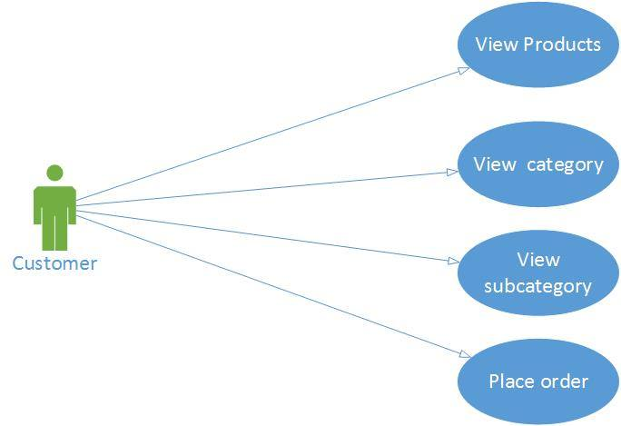

**Use Case Diagram for Customer**

**3.2.2Sequence Diagrams**

Sequence diagram is an interaction diagram. Interaction diagrams address the dynamic view of a system. Sequence diagram emphasizes the time ordering of messages between objects in the system.

The Sequence diagrams for this project based on.

* Administrator
* Customer
* Products Updation
* Cart

Here I will show the Sequence Diagrams of diagrams for both of the objects.

**3.2.2.1 Sequence Diagram For Admin Login**

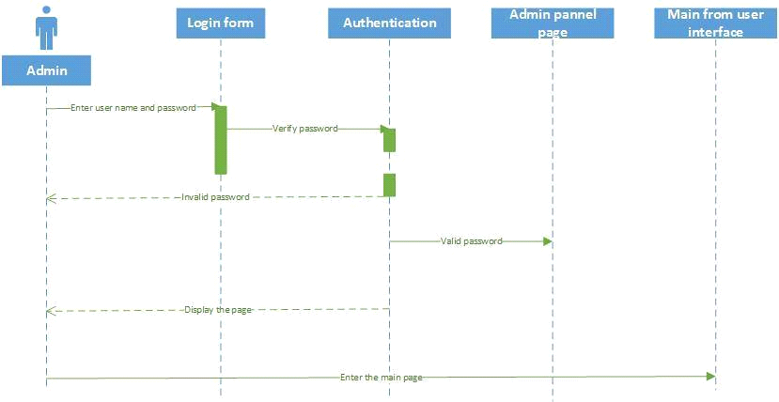

**3.2.2.2 Sequence Diagram for Product Updation**

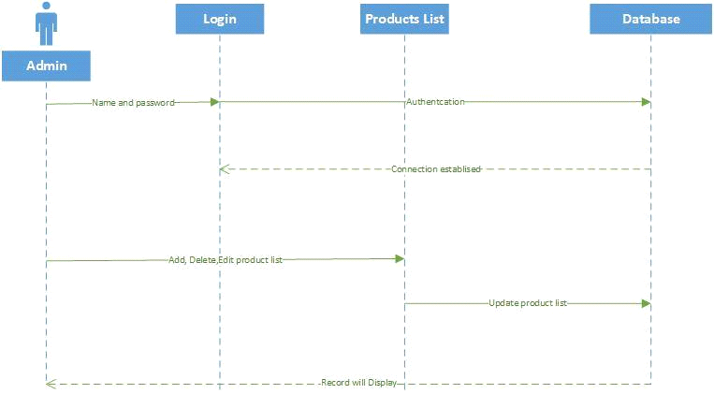

**3.2.2.3 Sequence Diagram Forcustomers orders**

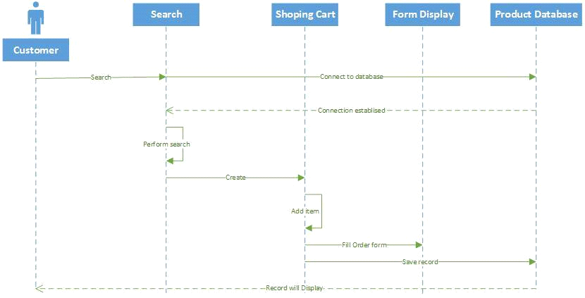

**3.2.2.4 Sequence Diagram for Check Orders**

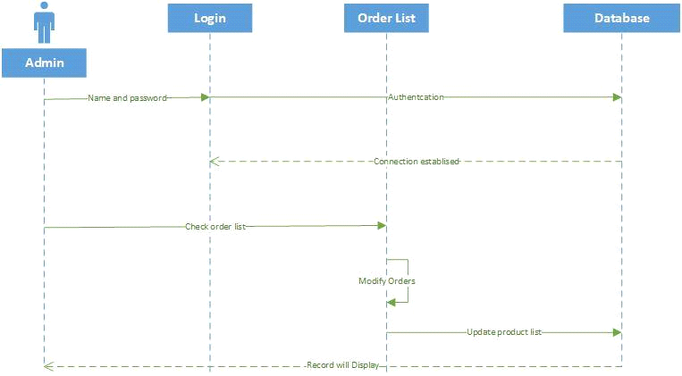

**3.3Data Flow Diagram**

Data flow diagrams illustrate how data is processed by a system in terms of inputs and outputs.

**3.3.1 DFD Level 0**

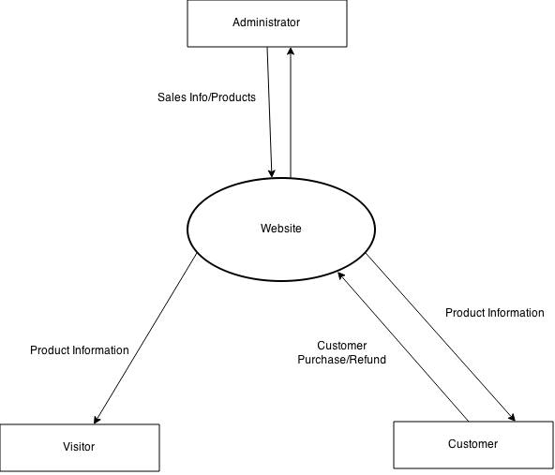

**3.3.2 DFD Level 1**

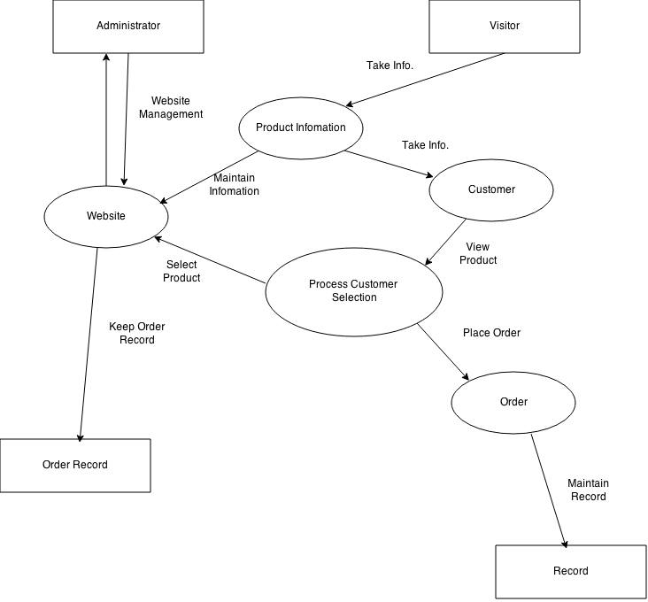

**3.4Database Design**

The most important phase of any project is the designing of database which involve the designing of different normalized tables and then the relationship between those normalized tables.

For input designing, table designing is done. There are several steps involved in developing an effective database design. The steps are such as, what data element must be stored, who will access them, and how.

**3.4.1 Database**

A database is collection of data, which is organized in such a way that each piece of data is available to those who need it and with minimum duplication of data.

Another definition in terms of database may be as “A database is a collection of data organized so as to minimize redundancy and maximize access.”

**3.4.1.1 Advantages of Database**

The most common advantages of database may be as follows:

* Minimal data redundancy
* Consistency of data
* Data integrity
* Sharing of data
* Ease of application development
* Uniform security, privacy and integrity controls
* Reduced program maintenance

**3.4.1.2 Constraints**

These are the conditions that obey database.

**3.4.1.3 Entity**

Any object or concept identified by an enterprise that exists independently and about which necessary to store data. It may be anything like a person, a place, an event, or concept or an object.

**3.4.1.4 Attributes**

These are the characteristics or properties of an entity that is of interest to the organization. For example Admin is an entity, its attributes mostly may be: Login name, Password etc.

**3.4.1.5 Keys**

A key is a distinct for each individual entity in an entity set. Key attributes are the attributes whose values are uniquely identified and do not exist again.

**1-Super Key**

A super key is an attribute or a set of attributes that uniquely identified an entity. For example, Login name is a super key because it can be used to identify each Admin uniquely.

**2- Primary Key**

The primary key is one or more column in a table used to uniquely identify each row to the table. Primary key values can’t be null and must be unique across the column. A multicolumn primary key is called Composite Primary Key.

**3- Foreign key**

Foreign key represents relationships between the tables or relations. A foreign key is a column (or a group of columns) whose values are derived from the primary/unique key of the same or some other tables.

**4- Composite Key**

If the key consists of more than one attribute for unique identification then it will be called as composite key.

Before description of tables, it is important to understand normalization.

**3.4.2 Normalization**

“Normalization” means putting a relation in to a higher normal. The purpose of normalization is to produce a stable set of relations that is faithful model of operations of the enterprise.

**3.4.2.1 Types of Normalization**

Following are major types of Normalization

* First Normal Form
* Second Normal Form
* Third Normal Form

**1-First Normal Form**

“A relation is in First Normal Form if and only every attribute is single valued for each tuple”. First Normal Forms does not allowed anyrepeating fields. An alternative way of describing first normal form is to say that the domains of the attributes of a relation are atomic.

**2- Second Normal Form**

“A relation is in Second Normal Form if and only if it is 1NF (first normal form) and all the non-key attributes are fully functionally dependent on the key.”

**3-Third Normal Form**

A relation is in third normal form if and only if it is in second normal form and no non-key attribute is transitively dependent on the primary key.

Third Normal Form can be defined as “A relation is in third normal form, if it is in second normal form and remove all transitive dependencies”.

**3.4.3 Entity Relationship Diagrams (ERDs)**

An entity is a data modeling technique that creates a graphical representation of entities, and relationship between entities in an information system.

There are entity relation diagram of my project. Firstly, I will show a single entity relation to other tables. After that I will show a complete relational model from these ERDs.

**3.4.4 Normalizing Relational Model to 3NF**

**3.4.4.1 Normalization Description of Tables/Relations**

Following are the normalized description of the tables.

**Table: Admin**

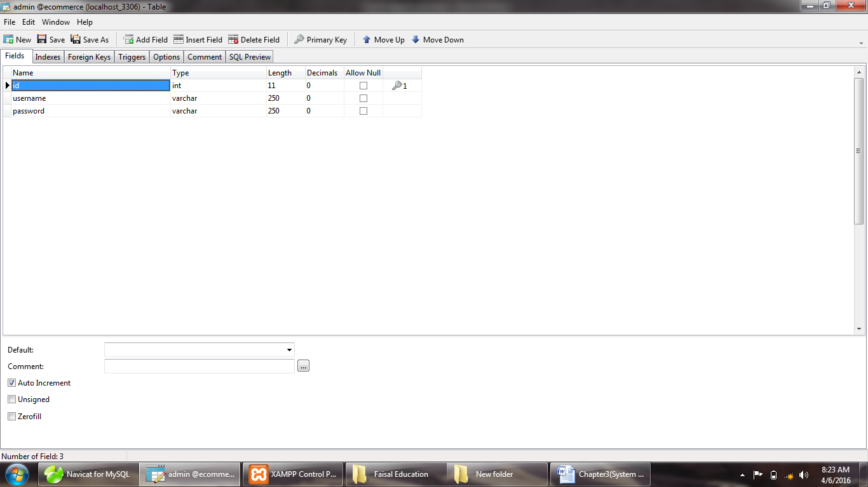

**Purpose:**For administrator use for logging in

**Table: Member**

**Purpose:**Use to store record of customer

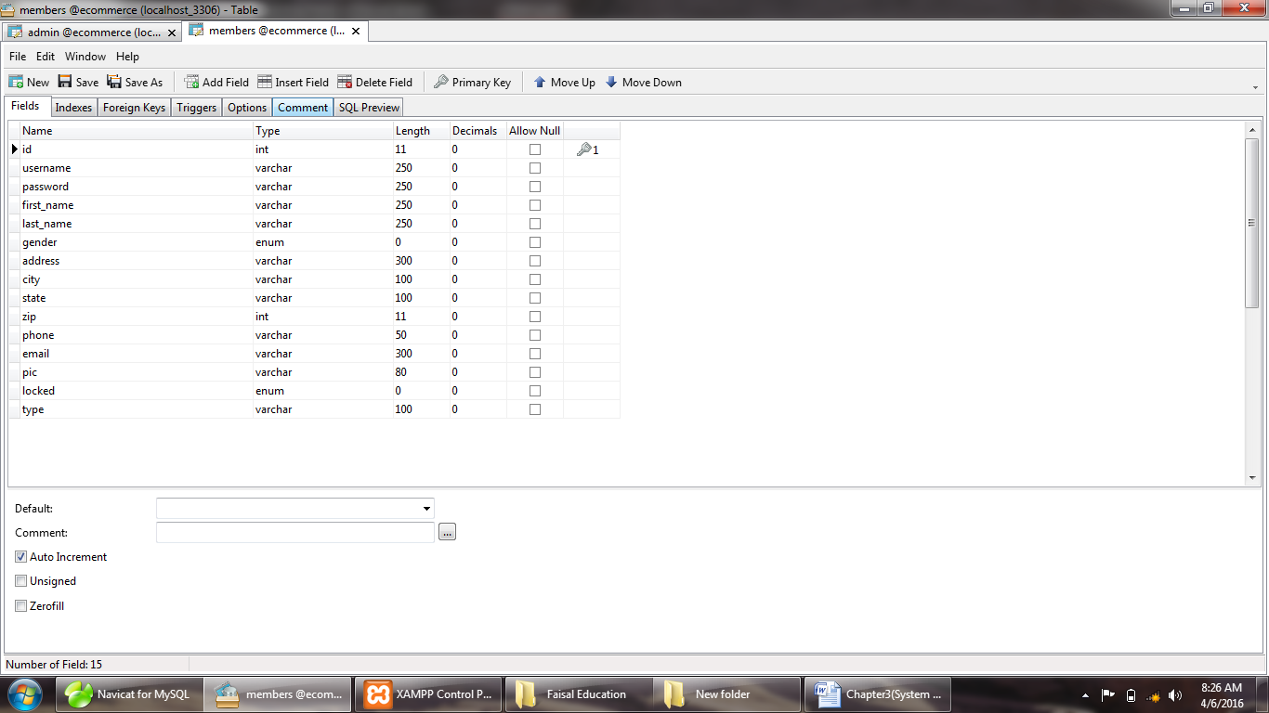

**Table:order-detail**

**Purpose:**Use to store record of Product

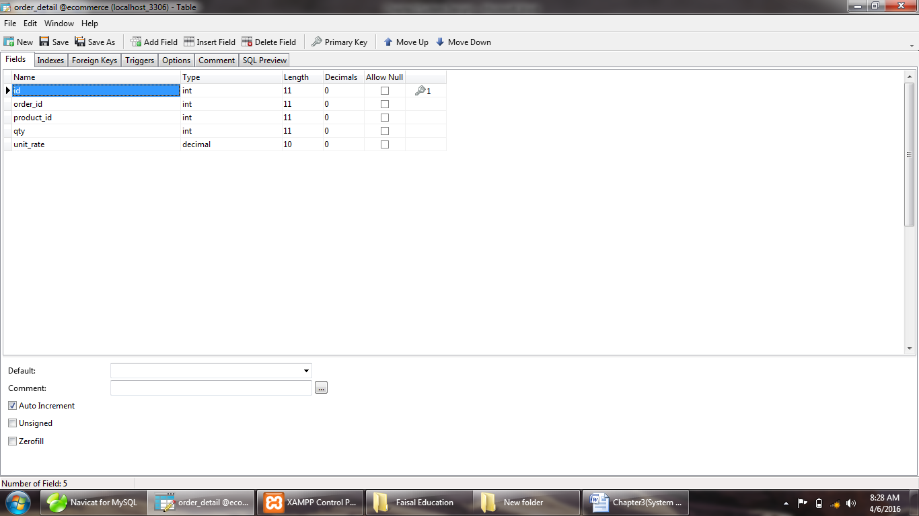

**Table: order**

**Purpose:**Use to store record of Categories and Subcategories.

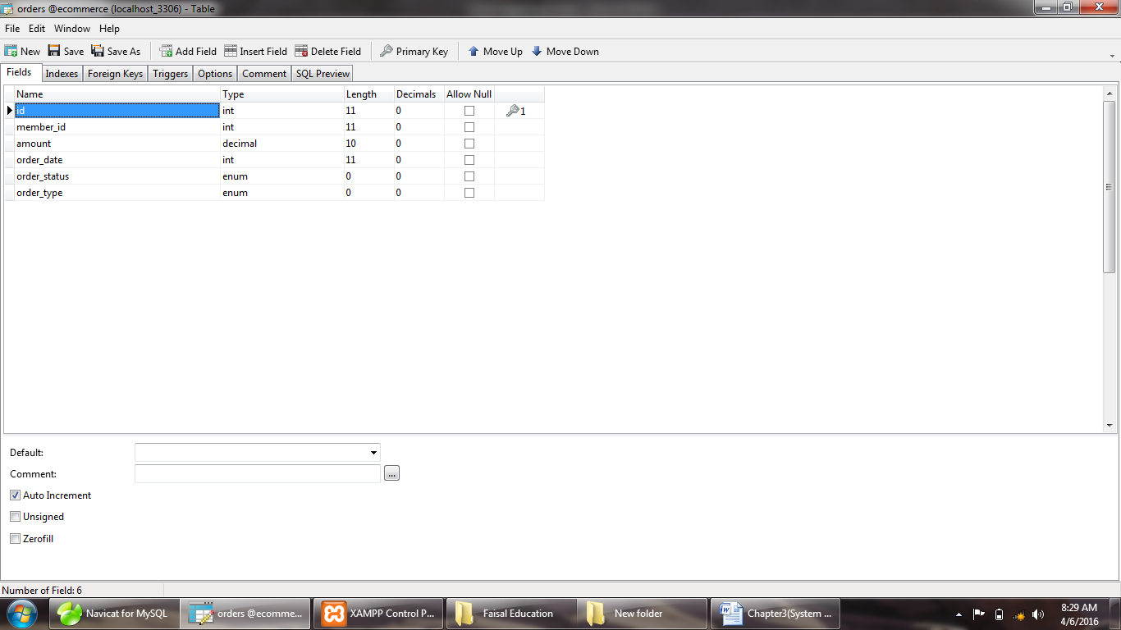

**Table: product**

**Purpose:**Use to store record of products

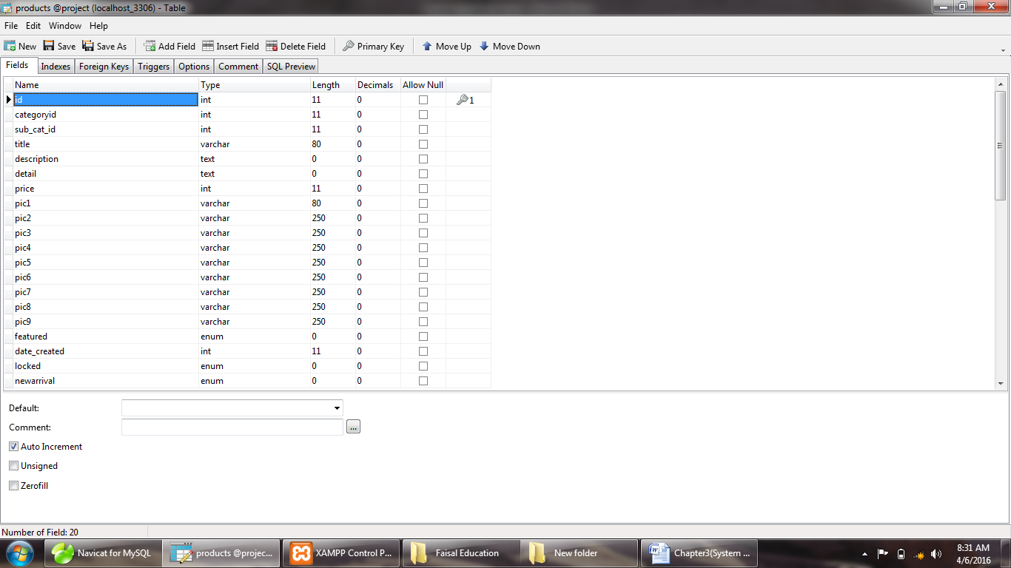

**Table: product-categories**

**Purpose:**Use to store record orders of customer

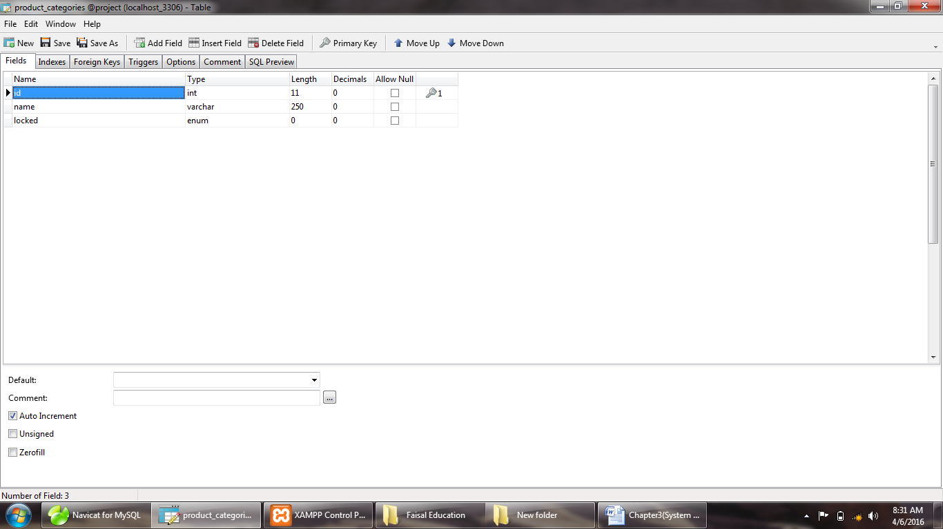

**Table: product-subcatagories**

**Purpose:**Use to store record of product on order detail,

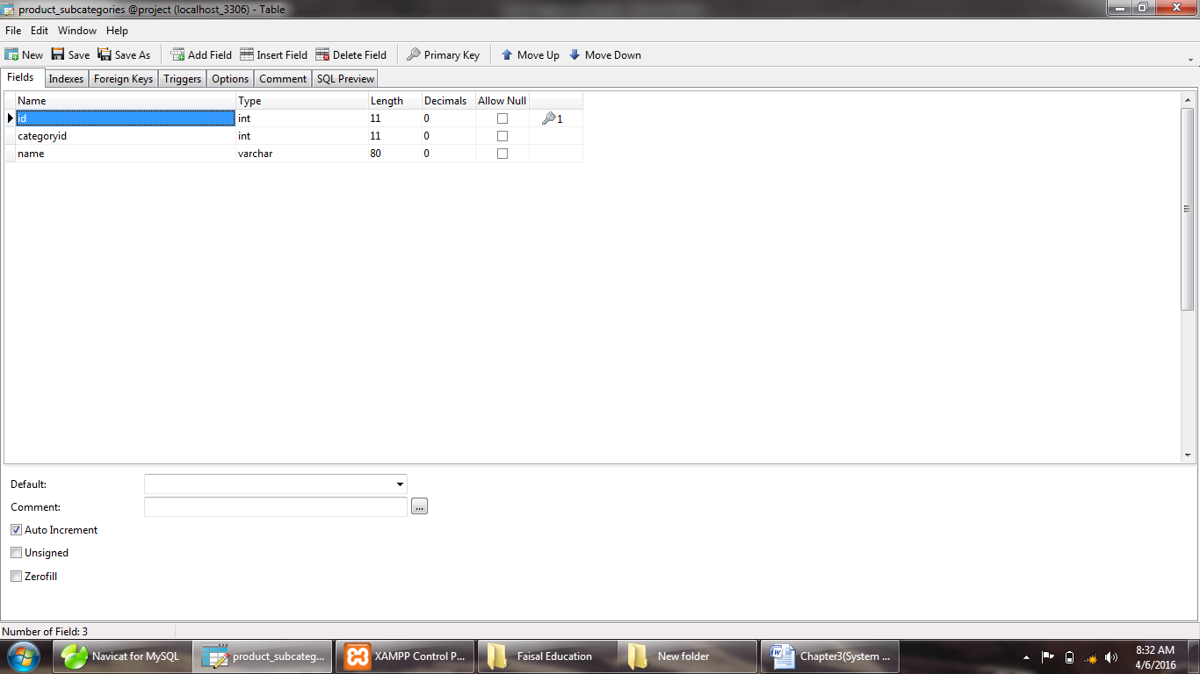

**Chapter No 4**

**System Development**

* 1. **Introduction**

Web Application is information transformation, producing, managing, acquiring, modifying,Displaying and transmitting information.

In computing, a web-based application is any application that uses a web browser as a client. The term may also mean a computer software application that is coded in a browser-supported programming language (such as JavaScript, combined with a browser-rendered markup language like HTML) and reliant on a common web browser to render the application executable.

Web applications are popular due to the ubiquity of web browsers, and the convenience of using a web browser as a client, sometimes called a thin client. The ability to update and maintain web applications without distributing and installing software on potentially thousands of client computers is a key reason for their popularity, as is the inherent support for cross-platform compatibility. Common web applications include webmail, online retail sales, online auctions, wikis and many other functions.

**How do web applications work?**

The figure below details the three-layered web application model. The first layer is normally a web browser or the user interface; the second layer is the dynamic content generation technology tool such as Hypertext Preprocessor (PHP), and the third layer is the database containing content (e.g., news) and customer data (e.g., usernames and passwords, social security numbers and credit card details).

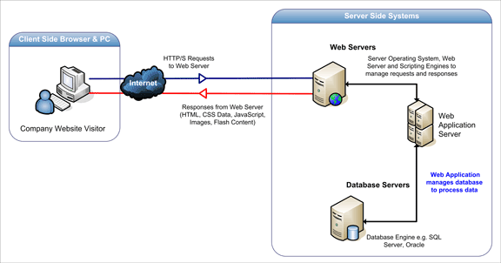

The figure below shows how the initial request is triggered by the user through the browser over the Internet to the web application server. The web application accesses the databases servers to perform the requested task updating and retrieving the information lying within the database. The web application then presents the information to the user through the browser.

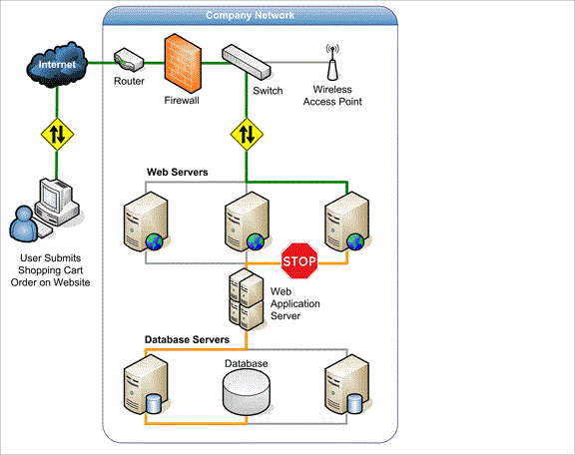

* + 1. **Hardware and Platform Requirement**

This web application can run on any Platform (smart phone, laptops,Ipad,tablet and pc)

or any type of operating system either it may be Android, Windows, linux or we can run this application on any browser it is fully browser compatible. The hardware failure or damage cannot effect this application.

* 1. **Hosting Server Selection**

Following are the specification for selecting the hosting server.

* *Domain 1*
* *Disk Space Usage 2 GB*
* *Monthly Bandwidth Transfer 30 GB*
* *Apache version 2.2.25*
* *PHP version 5.4.7*
* *MySQL version 5.5.27*
* *Architecture x86_64*
* *Operating system Windows7*
  1. **Testing modules**

**ACCEPTANCE TESTING**

Testing to verify a product meets customer specified requirements. A customer usually does this type of testing on a product that is developed externally.

**BLACK BOX TESTING**

Testing without knowledge of the internal workings of the item being tested. Tests are usually functional.

**COMPATIBILITY TESTING**

Testing to ensure compatibility of an application or Web site with different browsers, OSs, and hardware platforms. Compatibility testing can be performed manually or can be driven by an automated functional or regression test suite.

**CONFORMANCE TESTING**

Verifying implementation conformance to industry standards. Producing tests for the behavior of an implementation to be sure it provides the portability, interoperability, and/or compatibility a standard defines.

**FUNCTIONAL TESTING**

Validating an application or Web site conforms to its specifications and correctly performs all its required functions. This entails a series of tests which perform a feature by feature validation of behavior, using a wide range of normal and erroneous input data. This can involve testing of the product's user interface, APIs, database management,

security, installation, networking; etc testing can be performed on an automated or manual basis using black box or white box methodologies.

**INTEGRATION TESTING**

Testing in which modules are combined and tested as a group. Modules are typically code modules, individual applications, client and server applications on a network, etc. Integration Testing follows unit testing and precedes system testing.

**LOAD TESTING**

Load testing is a generic term covering Performance Testing and Stress Testing.

**PERFORMANCE TESTING**

Performance testing can be applied to understand your application or web site's scalability, or to benchmark the performance in an environment of third party products such as servers and middleware for potential purchase. This sort of testing is particularly useful to identify performance bottlenecks in high use applications. Performance testing generally involves an automated test suite as this allows easy simulation of a variety of normal, peak, and exceptional load conditions.

**REGRESSION TESTING**

Similar in scope to a functional test, a regression test allows a consistent, repeatable validation of each new release of a product or Web site. Such testing ensures reported product defects have been corrected for each new release and that no new quality problems were introduced in the maintenance process. Though regression testing can be performed manually an automated test suite is often used to reduce the time and resources needed to perform the required testing.

**SMOKE TESTING**

A quick-and-dirty test that the major functions of a piece of software work without bothering with finer details. Originated in the hardware testing practice of turning on a new piece of hardware for the first time and considering it a success if it does not catch on fire.

**STRESS TESTING**

Testing conducted to evaluate a system or component at or beyond the limits of its specified requirements to determine the load under which it fails and how. A graceful degradation under load leading to non-catastrophic failure is the desired result. Often Stress Testing is performed using the same process as Performance Testing but employing a very high level of simulated load.

**SYSTEM TESTING**

Testing conducted on a complete, integrated system to evaluate the system's compliance with its specified requirements. System testing falls within the scope of black box testing, and as such, should require no knowledge of the inner design of the code or logic.

**UNIT TESTING**

Functional and reliability testing in an Engineering environment. Producing tests for the behavior of components of a product to ensure their correct behavior prior to system integration.

**WHITE BOX TESTING**

Testing based on an analysis of internal workings and structure of a piece of software. Includes techniques such as Branch Testing and Path Testing. Also known as Structural Testing and Glass Box Testing.

**Chapter No 5**

**User guider**



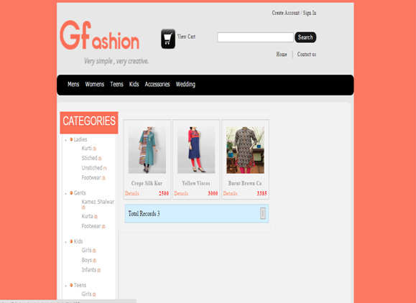

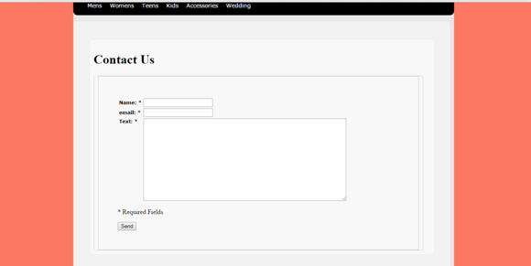

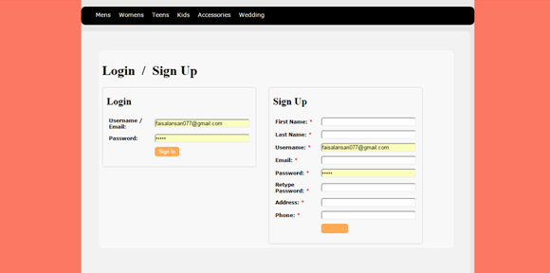

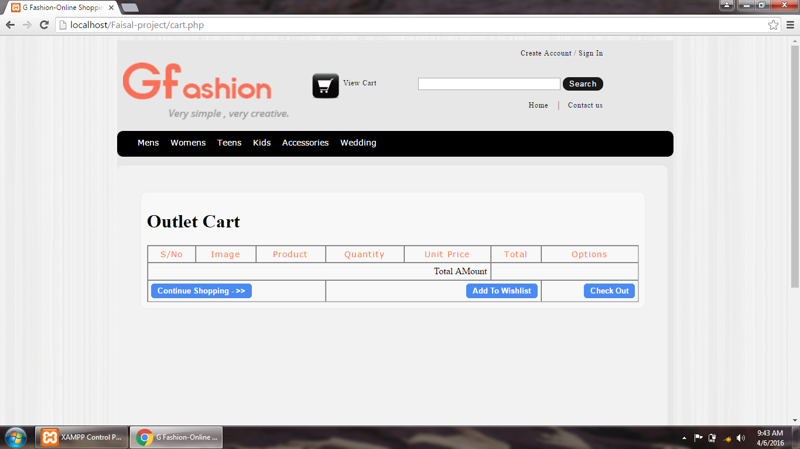

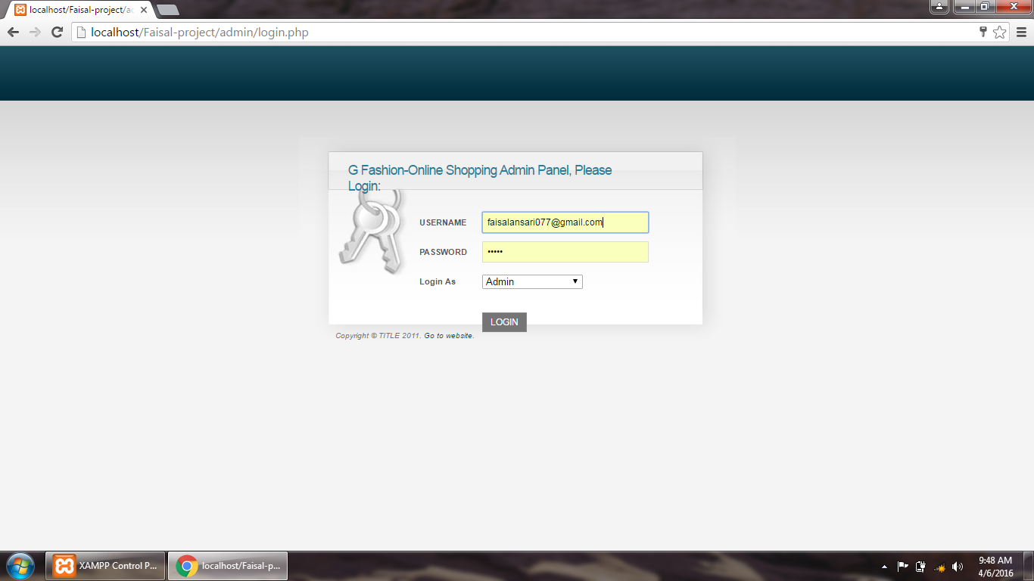

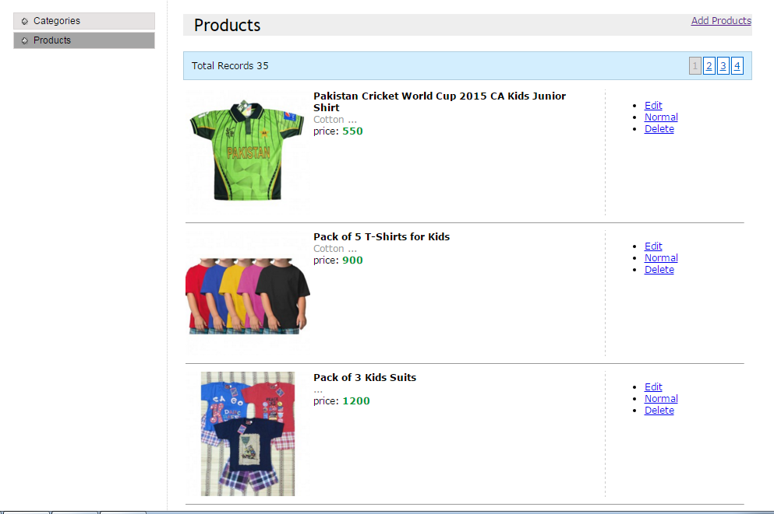

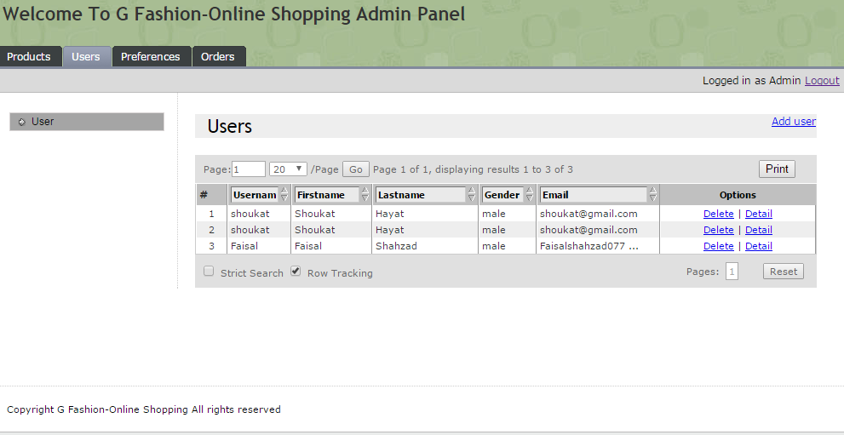

**Chapter 6**

**Conclusion**

**Conclusion**

This Inventory Control web application provides flexibility to reduce carrying costs, minimize excess or obsolete inventory, improve cash flow, and increase customer service levels. Distribution software captures information on inventory changes, allowing for accurate data when making purchasing decisions. Staff will no longer run to the warehouse to confirm item availability, in this application at any time staff can check the current status of the stock. This application can open on any device i.e. smart phone, iPod, laptop, system. So owner of the company can check the status of his company at any time and any place.

This is fully browser compatible so it can be work efficiently on any browser. The template of the application is made on DWT (Dreamweaver Templates) which provides the following facility:DWT files are used to create multiple Web pages in Dreamweaver. The user can define editable regions within the template; changes to non-editable areas will affect all pages designed through the template. The main advantage of using DWT is that all the template is load in when the web page is opened and permanent saves in browser cache so this technique improve the loading time of web pages.

The advance searching and table sorting techniques are also used in this web application which proved to be helpful for the client, this application that is developedhaving easiest interface and in simple language so that person with less knowledge of computer can use this web application efficiently.

The computerized invoice can also provide flexibility to the user before the development of this system G-fashion shop are using the file base system so in manual invoices there are lot of chances for occurring the errors, but now in this application there have no chance for occurring the error. Client side scripting is also provided, as users do any mistake it catches it and will give the warning to the user.

Through this web application, we can also maintain the record of the venders, buyers and the salesman. There is also a portion available for maintaining the record of daily expenses and can generate daily expense sheet. This application can generate reports on the monthly weekly and for the single day, The reports can be printed or can be save in PDF format which are not easily changeable format, This feature helps the company’s important documents safe from unauthorized person. If we talk about the security of this application, it is fully secured and password protected application. So this application meets all the requirement of G-fashion shop